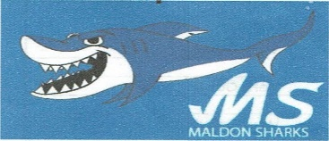
MALDON SHARKS ASSESSMENT FORM
Date:
NAME OF SWIMMER:
AGE:
CONTACT NAME:
EMAIL:
MOBILE NUMBER:
ASA SWIMMING LEVEL ACHIVED | DISTANCE AWARDS (if any)
7  8  9  10  11 | 200 meters  400 meters  800 meters  1 mile
SHALLOW DIVING CERTIFICATE | YES: | NO:
NAME OF CURRENT SWIMSCHOOL
IF CURRENTLY RECEIVING LESSONS Weekly | Half Hour | One Hour
NAME OF CURRENT SWIMMING CLUB | ASA No:
How did you hear about Maldon Sharks Swimming Club
Web - email | Web - club phone
SWF | Blackwater
Personal recommendation | Other

